Human Sleep Patterns & Stress — Part 4: Hypothesis Testing Summary
Problem Statement
A friend shared 179 daily sleep records from a wearable tracker (1 Nov 2021 – 30 Apr 2022). The question is whether the proportion of nights with adequate sleep (≥ 7 hours) is greater than 75 %. Formally:
H₀: p = 0.75 vs H₁: p > 0.75 (right-tailed test for a single proportion).
Solution Strategy
1. Compute sample proportion of nights with Hours of Sleep ≥ 7 (count / n).
2. Form the z-statistic under the null: z = (p̂ − 0.75) / √[0.75·0.25 / n].
3. Obtain the one-sided p-value from the standard normal distribution.
4. Decide at α = 0.05 and α = 0.10. Cross-check with statsmodels and an exact binomial test.
5. Extend: t-test on mean hours, high Sleep-Score proportion, correlations, monthly trends, bootstrap CI and sensitivity simulation.
Solution
Main test results: count = 140, n = 179, p̂ = 0.7821, SE = 0.0324, z = 0.9925, p-value = 0.1605.
Decision: Fail to reject H₀ at both 5 % and 10 % significance levels. Although 78.2 % of nights meet the guideline, the excess over 75 % is not statistically significant.
Alternate methods give essentially the same conclusion (statsmodels z identical; exact binomial p ≈ 0.183).
Mean sleep duration = 7.56 h (one-sided t-test vs 7: t = 10.43, p ≈ 10⁻²⁰ — highly significant). Sleep Score is most strongly associated with % Heart-Rate-Below-Resting (r = 0.50). November and February show the lowest adequate-sleep proportions (~67 % and ~71 %).
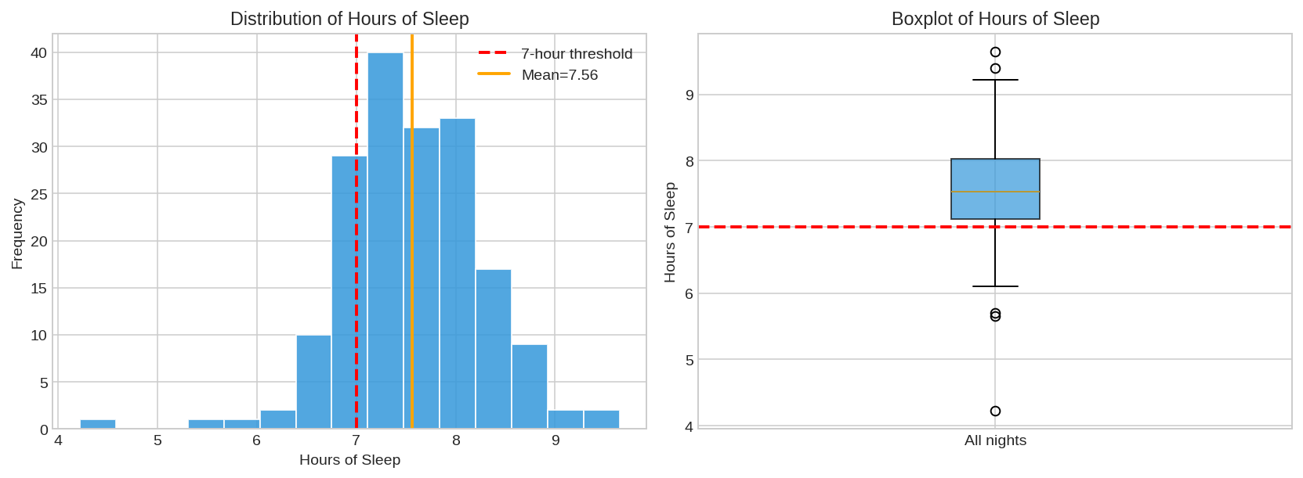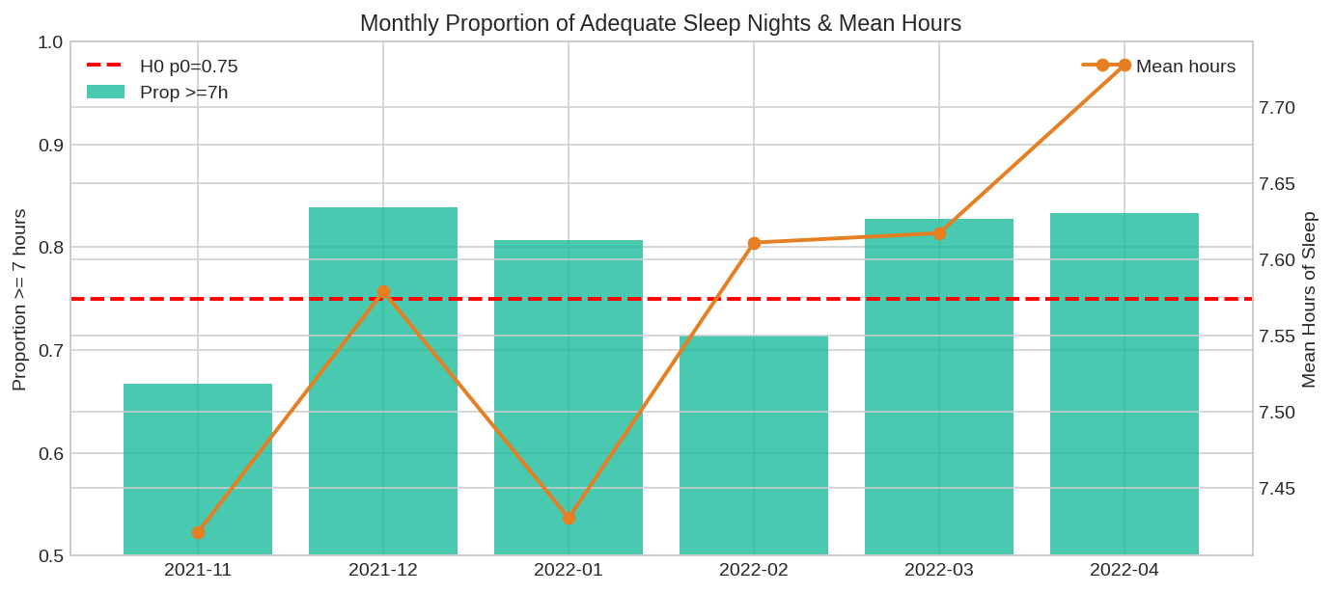
Key Takeaways
• Cannot claim the long-run proportion of ≥ 7-hour nights exceeds 75 % with the present sample; the 95 % bootstrap CI is [0.72, 0.84] and contains 0.75.
• Average sleep is comfortably above 7 h; high Sleep Scores (≥ 85) occur on ~55 % of nights.
• Sleep quality (Score) tracks most closely with recovery physiology (HR below resting) rather than raw duration alone.
• Simulation shows the test becomes significant if the target is lowered to p₀ = 0.70 or the threshold is relaxed to 6.5 h; raising either bar quickly loses power.
• Practical advice: the friend is sleeping reasonably well on average; focus on consistency in weaker months (Nov, Feb) and on factors that improve overnight heart-rate recovery.
Data: 179 nights · Tools: Python (pandas, scipy, statsmodels) · Companion notebooks: Practice Skeleton + Solution

